Install Playwright:
We can find playwright documentation in: https://playwright.dev/docs/intro
We will install playwright using the command :
npm init playwright@latest.
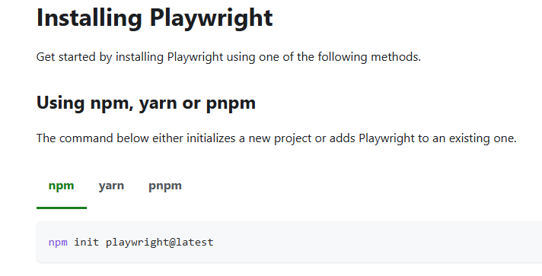
- We will select language as typescript.
- We will put E2E tests under test folder
- Install playwright browsers
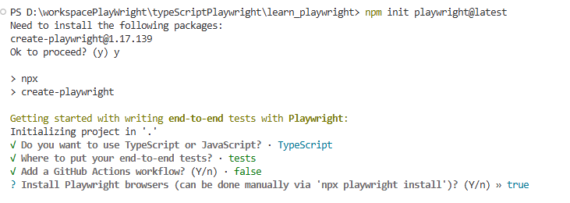
- Under node_modules we can see all the dependencies
- Under tests folder we can see the sample tests
- Under gitignore files we will find the folder which we will not include while pushing cod to git.
- Under package.json we will mention all the dependencies.
- Under playwright config we can add some properties.
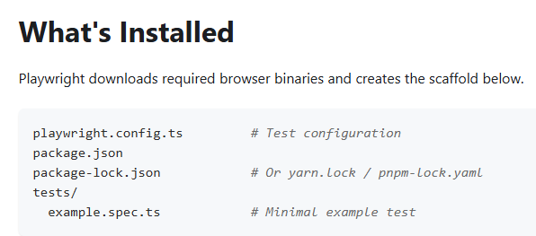
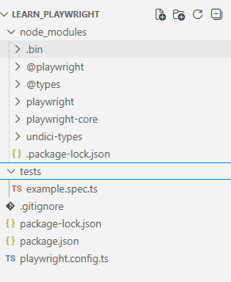
To execute the sample playwright script we use the command: npx playwright test
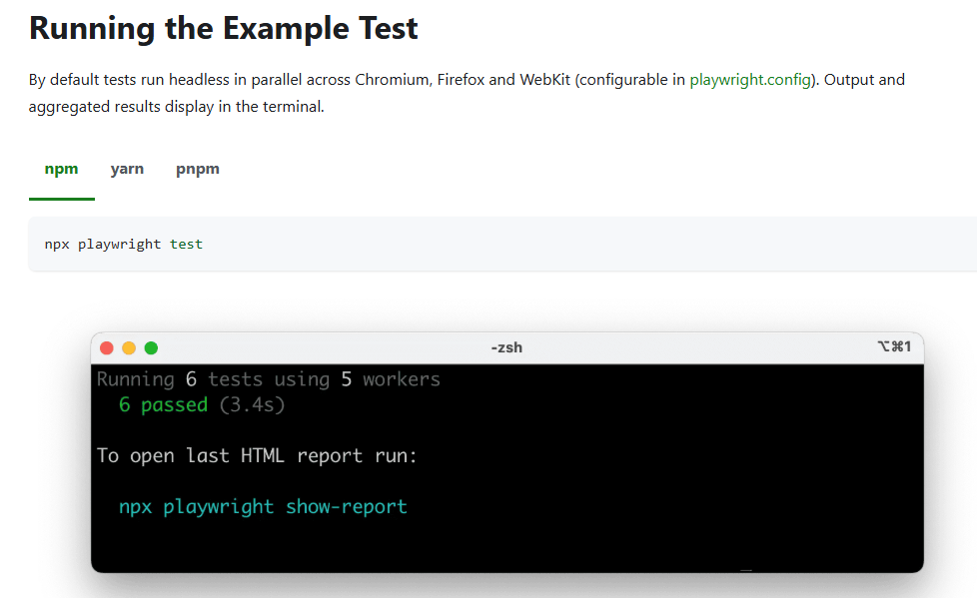
We see that 6 test is executed using 2 workers. This means that script got executed in parallel mode using 2 threads.
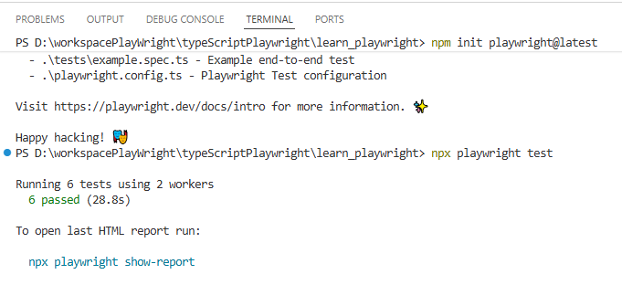
We can see the report using the command: npx playwright show-report
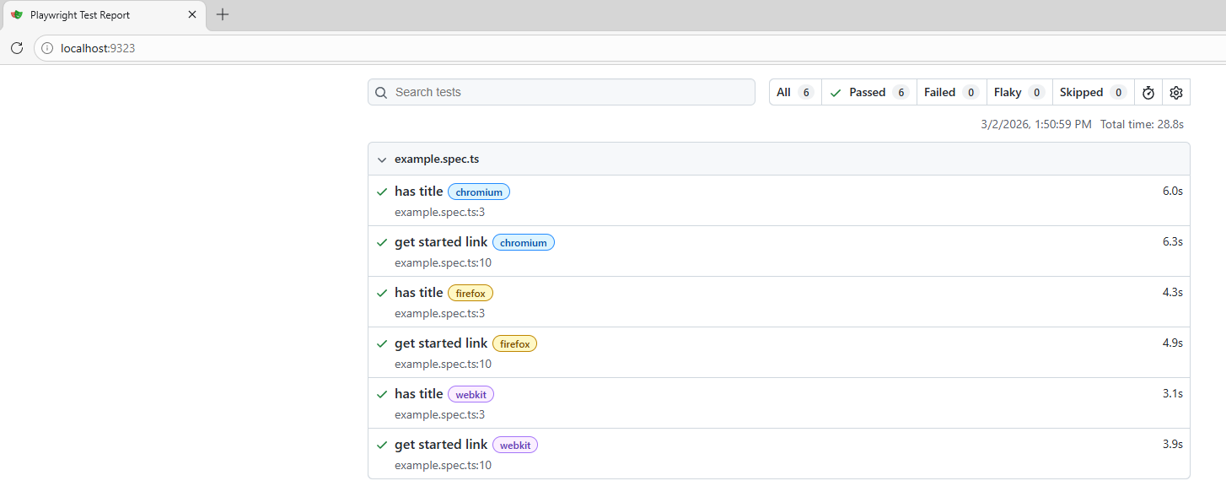
We can also install and extension called playwright test.
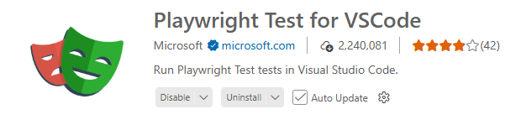
Once installation is done click on View -> Command Pallets
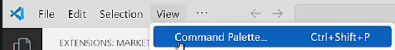
Select Test install playwright.
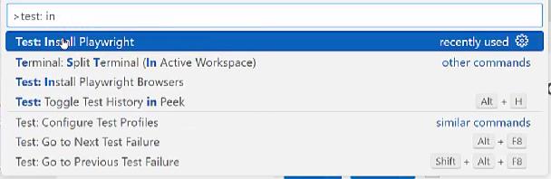
Select only chromium and firefox.
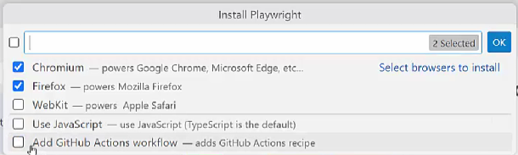
The benefit of this plugin is that we can see Run button beside each test.
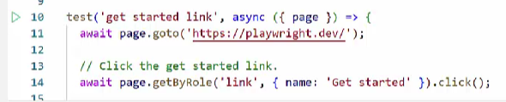
As of now script is getting executed in headless mode. To execute in real browser we add the following code in the configuration file.
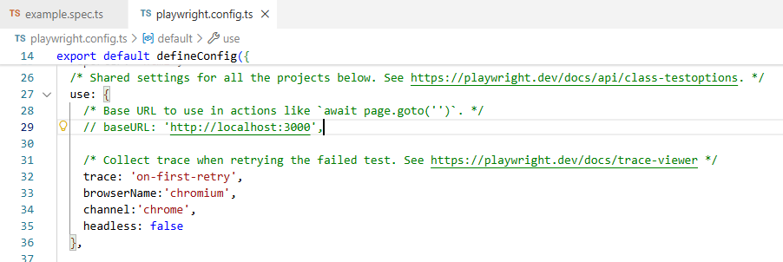

Write First test case:
We import test and expect from the playwright test packet which is the testing library of playwright.
“Test” is used to write the test cases and “Expect” is used for assertions. If we remove test or expect we will start getting errors in our test.
Test is a function used to define individual test case. First parameter is the test name which describes the test. Async makes the function asynchronous. All playwright operations are asynchronous such as interaction with the page, waiting for an element, clicking an element, navigating to a page. Whenever we use an asynchronous function we will use the async keyword.
Page is an instance of playwright page class. We use it to interact with browser page by calling method as navigating, clicking, typing etc. Await keyword is used to ensure before each user interaction. %this ensures that first operation is completed before the next operation is triggered. Since playwright function returns promises we need to handle with async and await. We can also do the same operation using “then” if we don’t want to use await and async.
Page.title() -> returns the title of the web page.
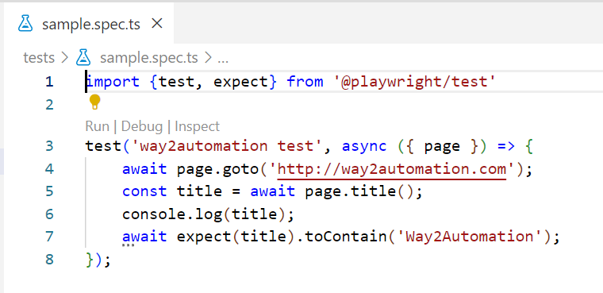

Browser Navigation Methods and Finding elements:
For learning purpose we will add some delay to the application so that we are able to see the execution.
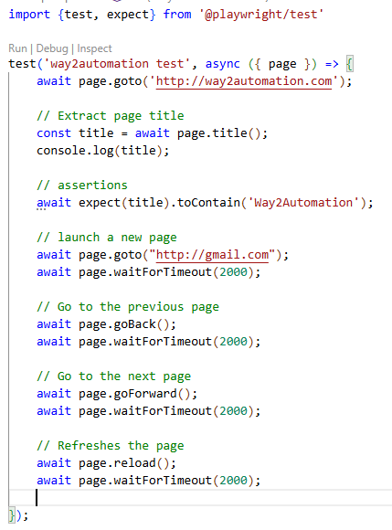
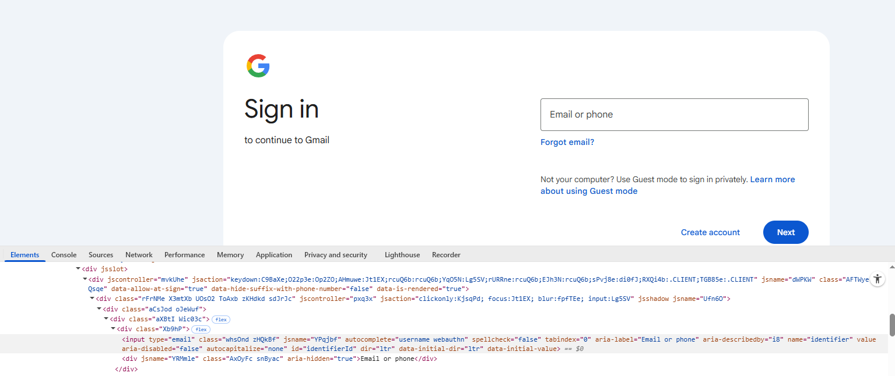
We open Gmail login screen and we see that login textbox has a property called “aria-label”.
Instead of identifying the element using “page.locator” we can use “page.getByLabel”.
Using “fill” we will enter text in the textbox.
One thing to note her is that there can be other element with the label as “Email Or Phone”. We can add some additional property in the form of regular expression. If we want exact match of the label we can use the property exact and set it to true.
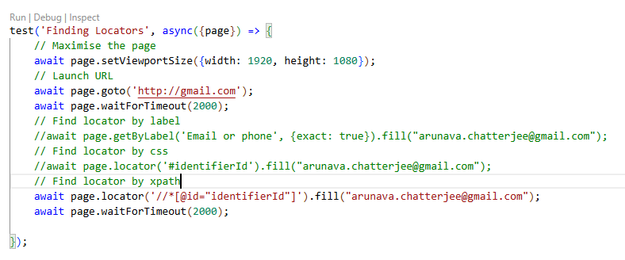
Next we would like to click on the next button.
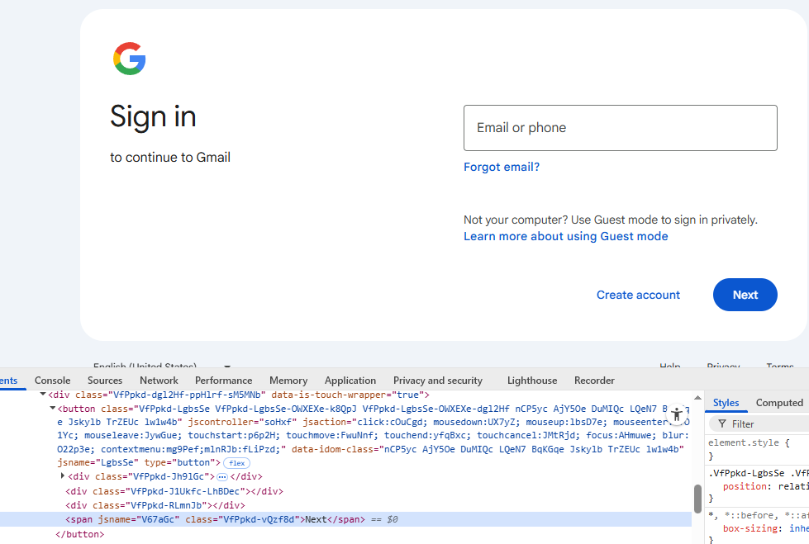
We see that next button is enclosed in button tag. We can put regular expression to filter by text.
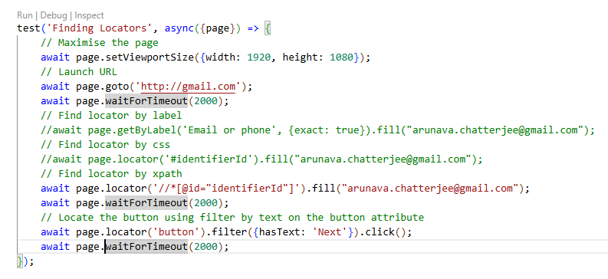
In case of Selenium when we needed to wait for an element using explicit wait but is handled internally in playwright.
Handling dropdown box:
Let us first see how to handle a dropdown box.
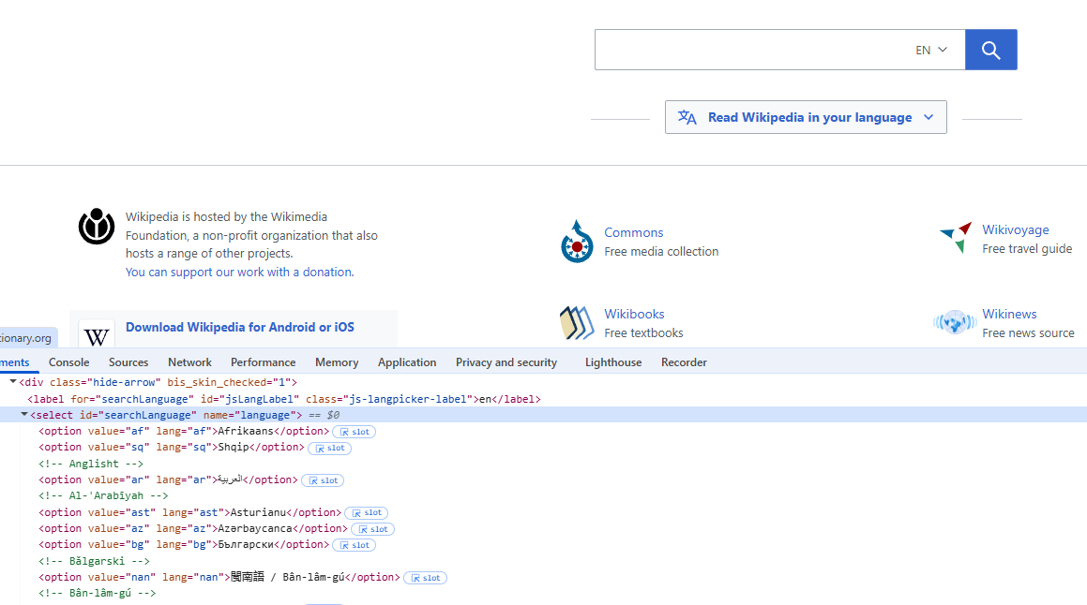
We can select element from dropdown box using 3 ways:
- Label
- Value
- Index
Within the select tag all the options are in the option tag. We can select all the options by applying all functions on the option tag.
Using innerText function we extract the text of the element and using getAttribute we fetch value corresponding to an attribute.
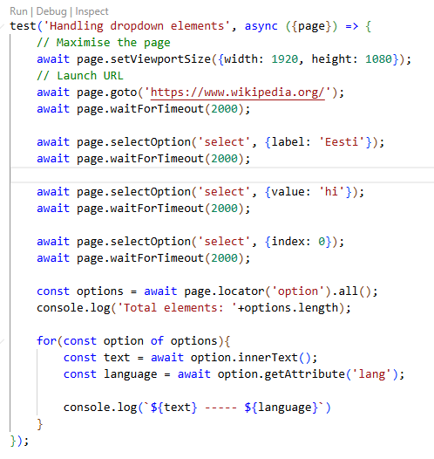
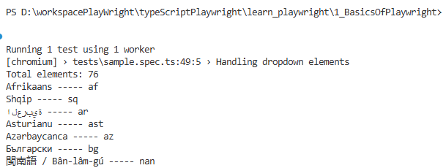

Handling links:
All the links are in the anchor (a) tag.
Using nth we can identify a single element from the list by passing the index.
In the footerNavBlock we have identified the footer elements. We can narrow down the search by passing indexes.
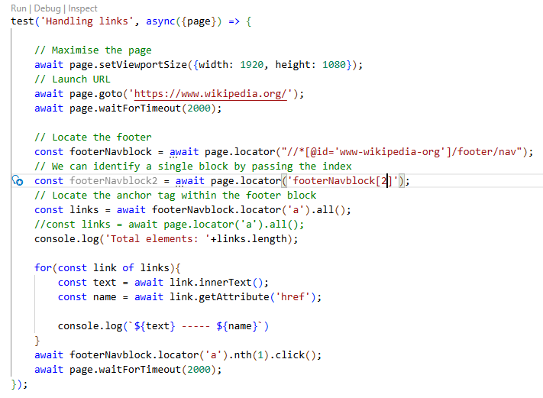

Handling Checkboxes:
Count function is used to count number of web elements.
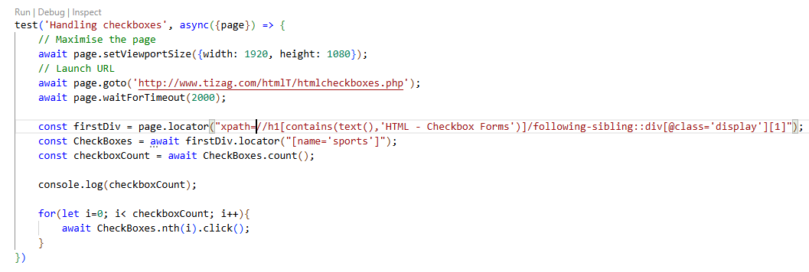
Assertions:
- toHaveURL -> verify the URL of the page
- not.toHaveURL -> verify whether the URL does not contain a particular text like error.
- toHaveTitle -> Verify title of a web page
- toHaveText -> Verify whether element has a particular text
- toBeVisible -> Verify whether element is visible
- toBeChecked -> Verify whether checkbox or radio button is checked.
